You will need the following parts:

Make sure the parts are printed from heat resistant material. ABS is fine, just be careful if using anything containing acetone near ABS parts.

3 of 'Support ring section 1'

If you have a heater with wiring entering on it's perimeter, you will need:
1 of the 'Support ring section 2 slotted' and
2 of 'Support ring section 2'

If your heater element has wiring attached away from the perimeter you will need:
3 of 'Support ring section 2'

6 of 'Glass clamp' (If these tighten down onto the ring without securing the glass sufficiently, try the 'Glass clamp extended chamfer'

3 of 'Support arm'

1 of 'Lock ring'
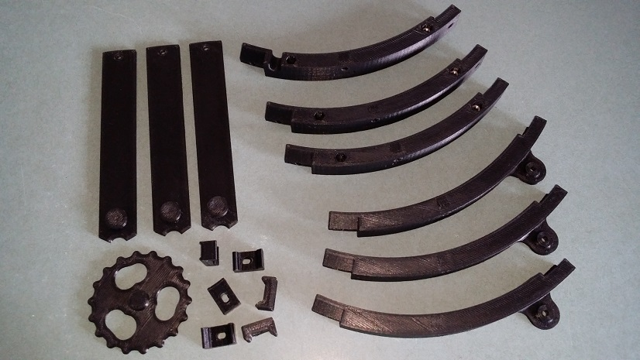

Start by assembling the ring using the M3X10 bolts and half-nuts.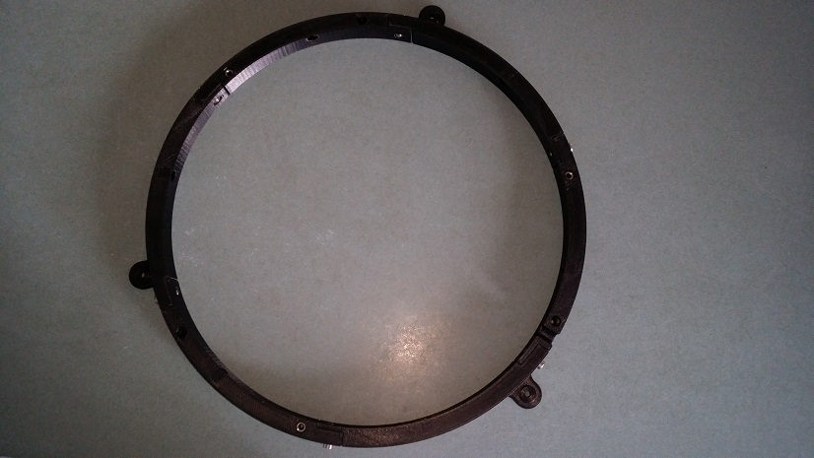

Attach the glass clamps using M3X16 bolts, but leave them fairly loose.
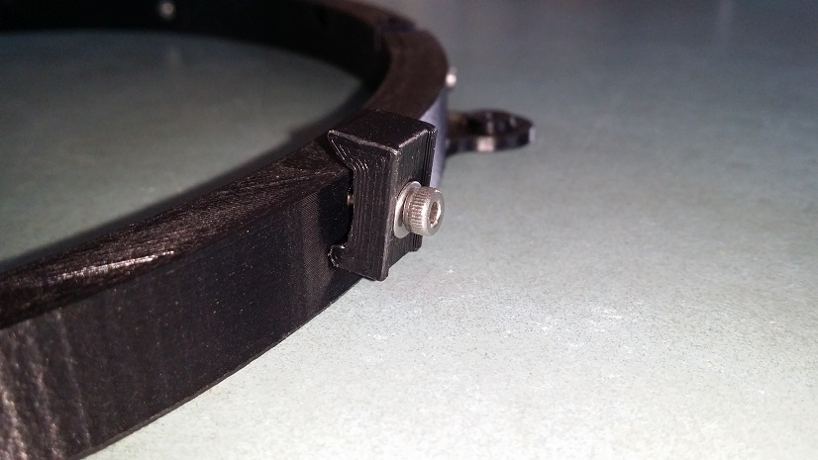

Insert 3 M3 half-nuts into the position where you will attach the bed support.

Sit the glass plate on the ring and tighten the glass clamps.

Insert the heater. If using a heater with wiring attached to the edge, feed this through the slot.

With the bed glass side down, insert your insulating material.

Place the solid cover over the insulating material.

To assemble the bed support, place the 3 support arms with the cutouts forming a circle in the middle.
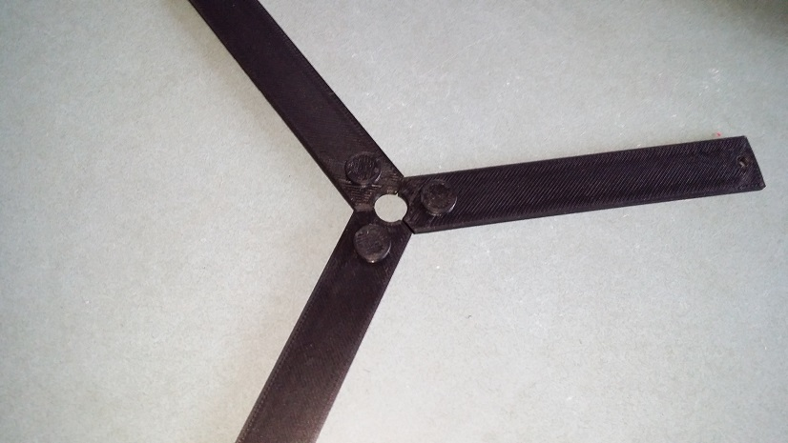

Place the lock ring over the arms and turn it to lock the arms together.
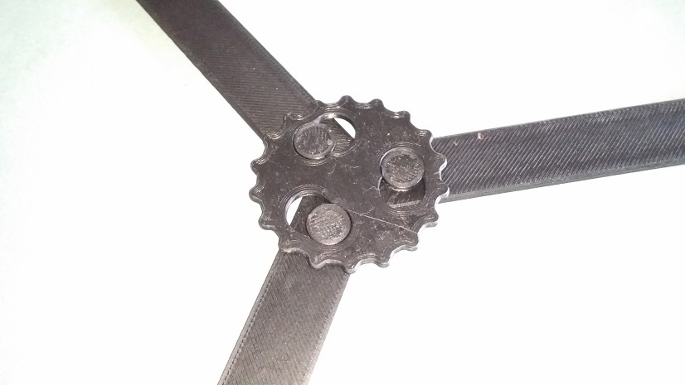

Attach the support assembly to the bed using M3X16 bolts.

Plug your wiring into your controller and attach the bed to the printer.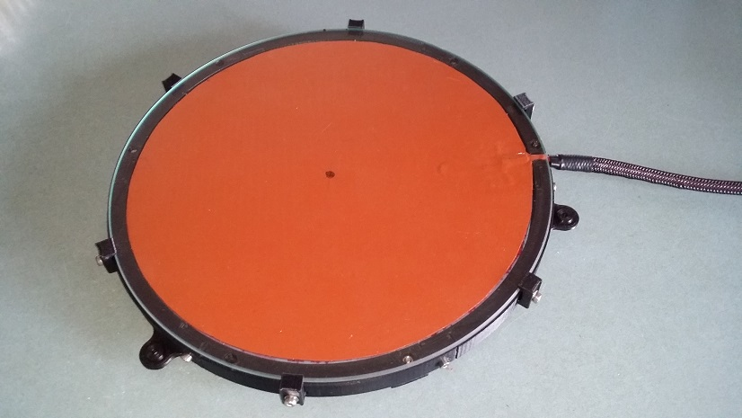

Enjoy :)

